**Project Initialization and Planning Phase**

| Date | 7th July 2024 |
| --- | --- |
| Team ID | SWTID1720161281 |
| Project Name | Ecommerce Shipping Prediction Using Machine Learning |
| Maximum Marks | 3 Marks |

**Define Problem Statements (Customer Problem Statement Template):**

Online shoppers frequently encounter uncertainty and delays in receiving their ordered products due to unreliable shipping estimates provided by ecommerce platforms. This inconsistency often leads to frustration and dissatisfaction among customers, impacting their overall shopping experience negatively. Customers desire accurate and reliable predictions of shipping times at the point of purchase to make informed decisions and manage expectations effectively. Therefore, there is a critical need to develop a machine learning solution that can predict shipping times accurately based on various factors such as product availability, shipping location, and historical shipping data. By addressing this challenge, ecommerce platforms can enhance customer satisfaction, improve trust in their services, and ultimately increase repeat purchases.

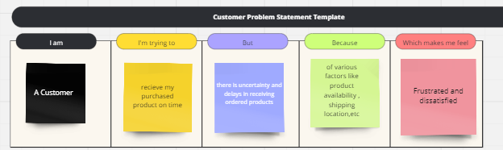

|  |  |  |  |  |  |
| --- | --- | --- | --- | --- | --- |
| **Problem**  **Statement (PS)** | **I am**  **(Customer)** | **I’m trying to** | **But** | **Because** | **Which makes me feel** |
| PS-1 | A Customer | Receive my purchased product on time | There is uncertainty and delays in receiving ordered products | Of various factors like product availability, shopping location ,etc. | Frustrated and dissatisfied |